Magento – Ecommerce website development

Create a Magento website

Task: 1 Page Management

In order to add new pages or edit the existing ones in Magento, you should go to the Content menu and click on the Pages option under Elements section.
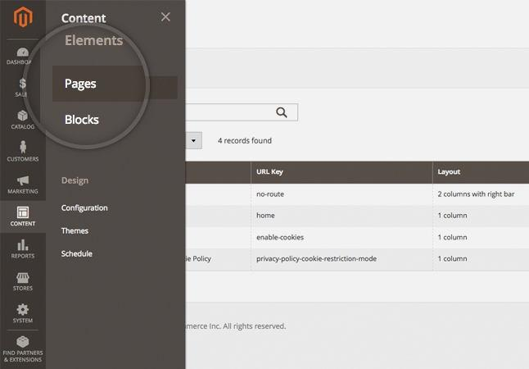

Magento 2 comes with 4 default pages but if you want to create a new one, you should click on the Add New page button.

1 | P a g e
Magento – Ecommerce website development
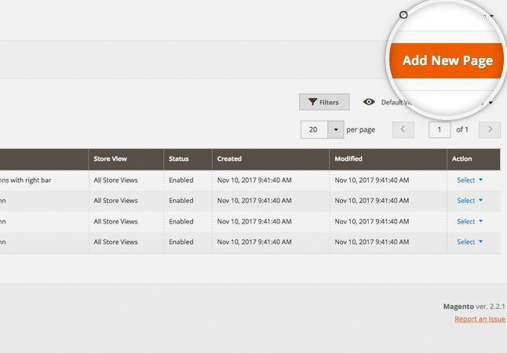

Clicking that button would redirect you to the new page addition option where you may add Page Title, Content Heading, Content, SEO options, Theme, etc.
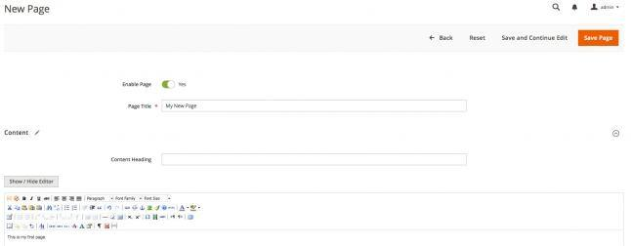

When you fill in the desired option - just click on the Save page button and that's it - you have added the new page.

In case you want to edit an already existing page, again go to the Content menu and click on the Pages option under Elements section. Now just choose the page you want to edit and click on it to preview the main editing options such as Title, URL key, Status, etc.

2 | P a g e
Magento – Ecommerce website development
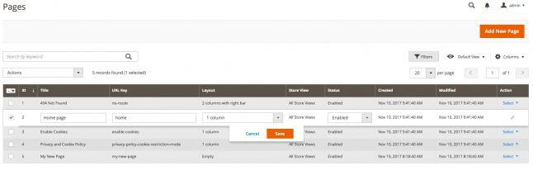

In case you want to edit other part of the page such as its content, you should expand the Select menu and click on the Edit button from the drop down menu.
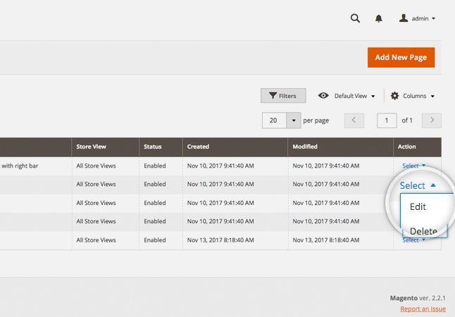

3 | P a g e
Magento – Ecommerce website development

Task 2: Product Adding

This section covers the following topics:

Add Products in Magento

Add Media to Your Products Manage Product Attributes

One of the most important parts of managing an e-commerce application is the products. In Magento this process consists of a few main parts.

Add Products in Magento

To add a new product in your Magento website you should go to the Magento admin panel > Catalog > Products. Afterwards click on the Add product button at the top right of the page.
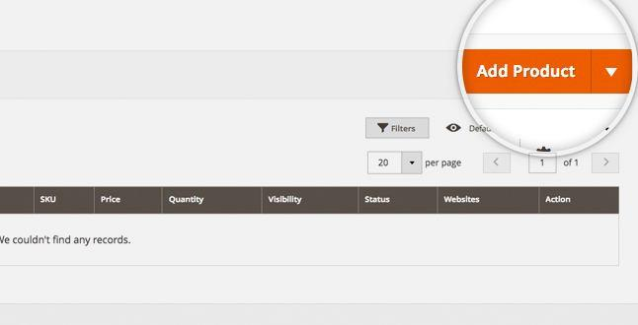

This would redirect you to the next page where you should input the product's options like Attribute set, Product name, SKU, price, etc. There is also option to add Images, Videos, setup URL key and much more. You may review all of the available options when you scroll down. You may also add a new attribute if necessary by clicking on the Add attribute button.

4 | P a g e
Magento – Ecommerce website development
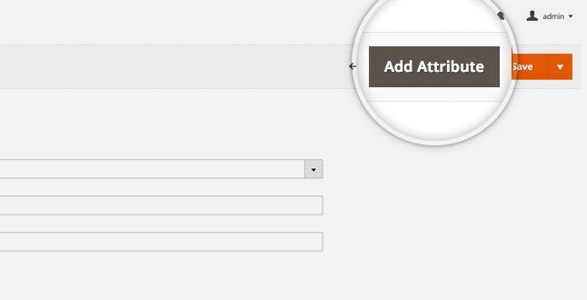

This would open a pop-up window which you may use to add the desired Attribute. When ready, click on the Save attribute button.
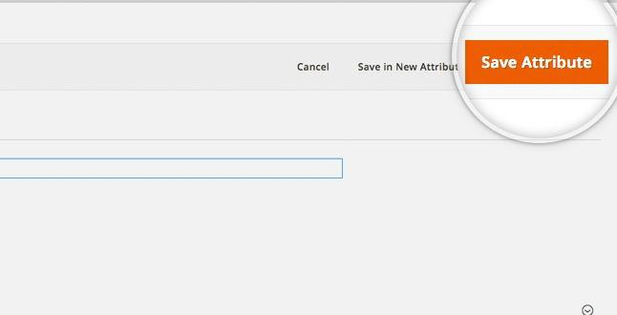

When you fill in the necessary details for your product - just click on the Save button

5 | P a g e
Magento – Ecommerce website development
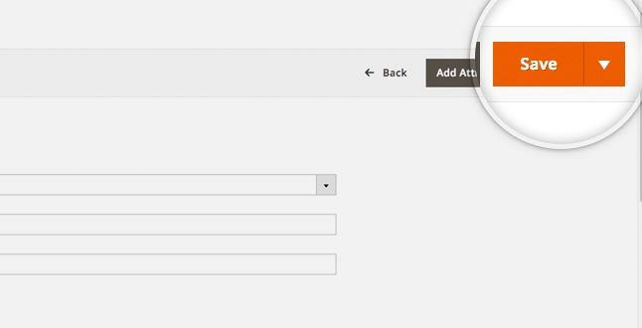

Add Media to Your Products

Adding an image to an existing product is easy in Magento. What you need to do is go to the Catalog > Products page and select the product you want to add image for or click on the Edit link in the Action menu.
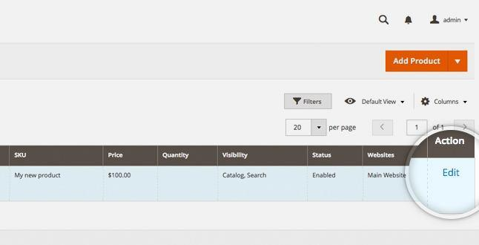

You will be automatically redirected to edit the product where you should scroll down to the Images and Videos section. To browse for an Image click on the Browse to find or drag image here icon. As the name of the icon suggests, Magento 2 provides the option to drag an image to upload it.

6 | P a g e
Magento – Ecommerce website development
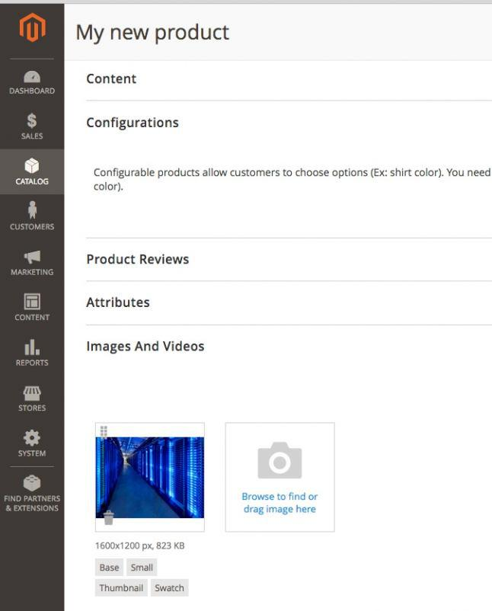

To add a video, just click on the Add Video button and a pop-up window would appear.

7 | P a g e
Magento – Ecommerce website development
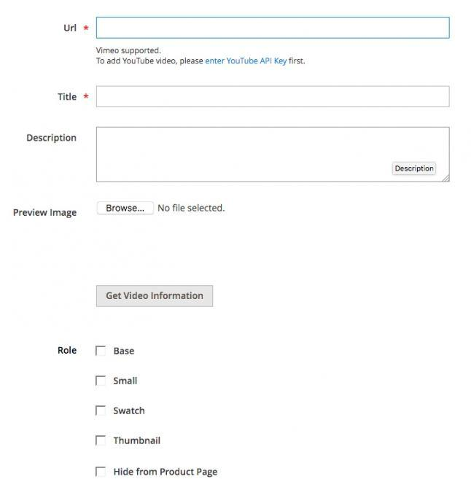

Here you may browse for video or fill in the URL of the video. Once ready - click on the Save button.

When the desired media is added - make sure to save the product using the Save button.

Manage Product Attributes

In order to access the available product attributes you should go to the Stores menu and select Product under the Attributes section.

8 | P a g e
Magento – Ecommerce website development
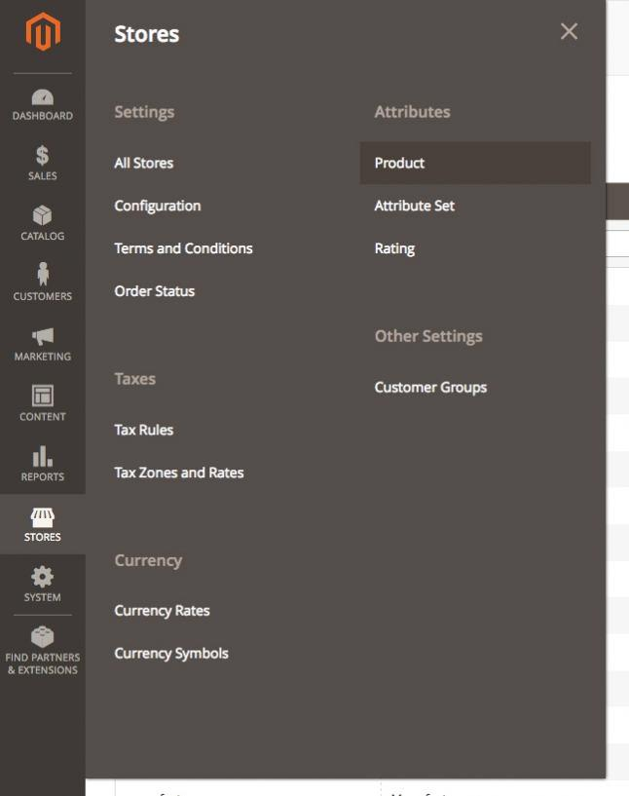

To create a new Attribute you should click on the Add new attriubute button.

9 | P a g e
Magento – Ecommerce website development
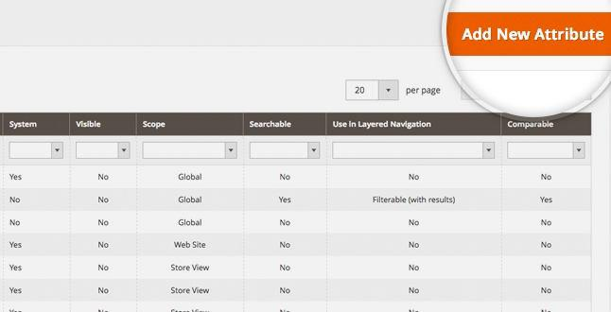

Once you are ready with the attribute, click on the Save Attribute button.
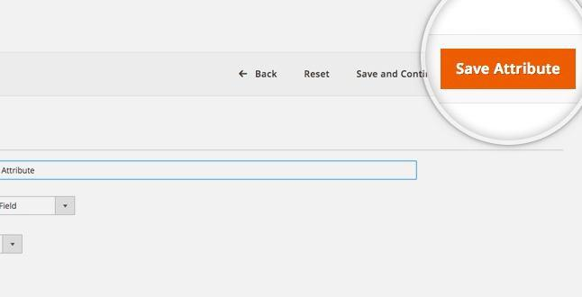

10 | P a g e
Magento – Ecommerce website development

Task 3:Payment Method

You may review the available payment methods in Magento via the admin panel by clicking on the Stores menu > Settings section > click on Configuration.
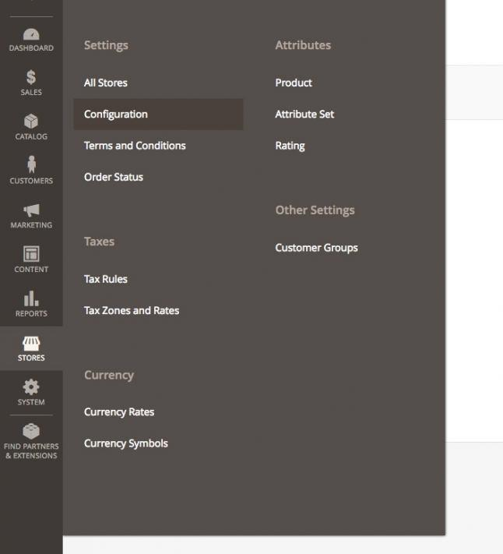

On the next page, expand the Sales menu on the left and select Payment methods.

11 | P a g e
Magento – Ecommerce website development
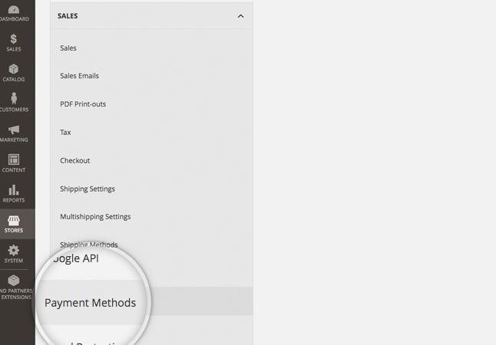

This way you may review all of the available payment methods on the newly opened page.
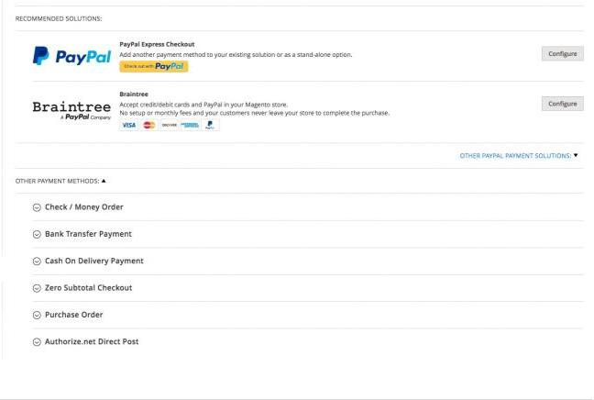

12 | P a g e
Magento – Ecommerce website development

For the purpose of this section we will enable the Braintree method which would allow you to accept credit/debit cards and PayPal in your Magento store. You may enable it by clicking on the Configure button next to it.

Enter the method's title, setup the environment (Sandbox or Production), define from which countries to accept payments, the range of the accepted payments and other options you want to alter.

In the Sort order field you should enter the position of this payment method compared to the other payment methods offered to the customers.

That's it, you have just enabled this payment method for your customers. Since all payment methods have different configurations, we cannot explain in details how to configure each one of them. Simply follow the instructions on their specific pages and they should work.

Task 4:Shipping Method

Before enabling the shipping method you should configure the shipping settings from the Stores menu > Settings section > click on Configuration > expand Sales > click on Shipping settings.

13 | P a g e
Magento – Ecommerce website development
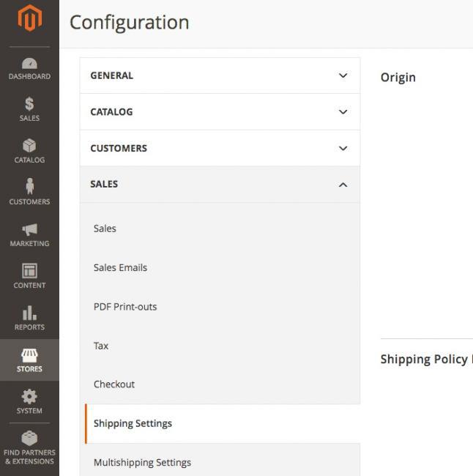

Expand the Origin section. Enter the address from which the shipping will be initiated. Usually this is the address of the warehouse where the products are stored. Afterwards open up the Multishipping settings in the Sales menu and expand the Options section. If enabled, the option Allow Shipping to Multiple Addresses allows goods from a single order to be shipped to different addresses. It is useful when a customer orders many products of a single kind, like post cards or pens for example and wants them to be delivered to multiple addresses. You can define the maximum number of allowed shipping addresses in the Maximum Qty Allowed for Shipping to Multiple Addresses field.

For example, to enable the USPS shipping module, you can go to Stores menu > Settings section > click on Configuration > expand Sales > click on Shipping methods and navigate to the USPS section.

14 | P a g e
Magento – Ecommerce website development
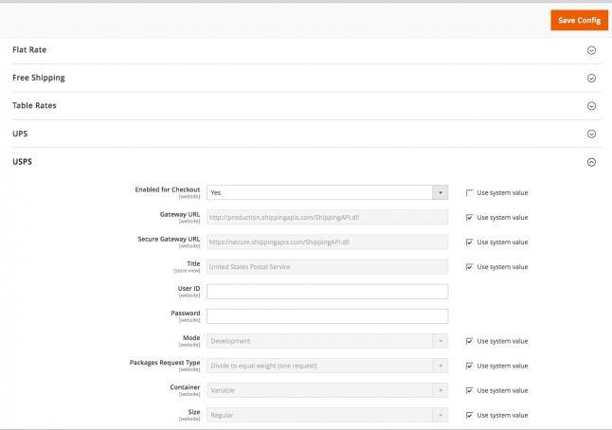

Then set Enabled for Checkout to Yes. The Gateway URL is needed to access USPS shipping rates. The field is preset by default, and normally does not need to be changed. The next step is to enter a Title for this shipping method that will appear during checkout. Afterwards Enter the User ID and Password for your USPS account. You may also adjust the Container to the type of packaging usually used to ship products ordered for your store, Size of the typical package. etc. In the Free method field you may choose the method you want to use for free shipping. You may also select None.

At the end you can define the countries for which the shipping is supported and the default error message in case the service is refused. In the Sort order field you should enter the position of this shipping method compared to the other shipping methods offered to the customers.

15 | P a g e
Magento – Ecommerce website development

Task: 5-Catalogue Creation

Import Products in Magento

It is rather inconvenient to manually add a large number of products at once to a Magento installation. Inserting products one by one will take a long time especially when you have hundreds or thousands of products. In such cases you need an automatic way to add all those products to your Magento online store. We will address all steps you need to take in order to achieve a successful import.

First, access your Magento administrator backend and go to Catalog -> Categories.
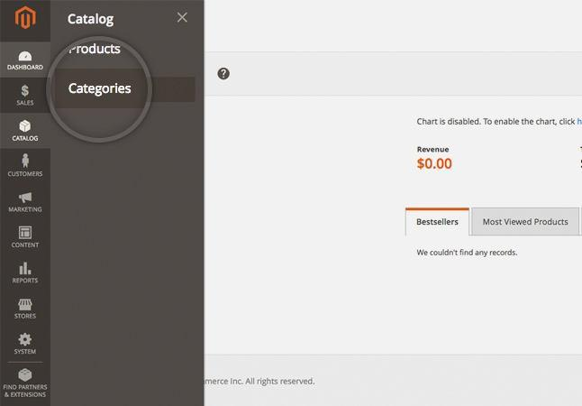

Create all product categories you will need. You can do so by filling the form displayed below:

16 | P a g e
Magento – Ecommerce website development
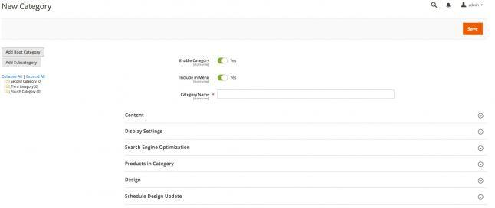

When you fill the form with all the information you like click the Save Category button.

Bear in mind that at this point you should make note of the newly created category IDs. It would be best to save them in a simple text file as you will need them for the import. The category ID will be displayed upon saving the category.

If you plan to have additional attributes for the products you are importing you will need to create those via Stores menu > Product under the Attributes section. You can use this functionality to add all custom attributes that are not present by default in a standard Magento installation. Note also that you can add additional attributes later at the moment you are creating a sample product. It is up to you whether to create the attributes before that or at the point you are creating the first product.

The next step is to manually add a product to your Magento installation. You will later export this product and use it as a template for importing the large batch. Make sure you include all attributes you will use for the products you are going to import in the sample product.

Once you create the new product and save it it will appear in the products list for your Magento store.
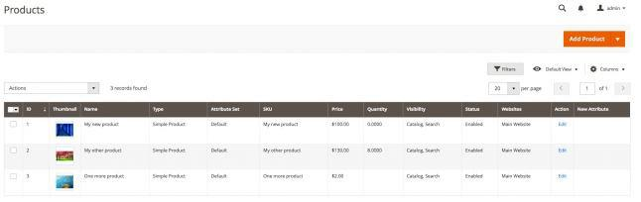

You are now ready to make the sample export that you will use as a template. In the Magento administrator area go to System menu > Data transfer section > Export. This would redirect you

17 | P a g e
Magento – Ecommerce website development

to a new page where you should select Products from Entity Type Dropdown and CSV from Export File Format.
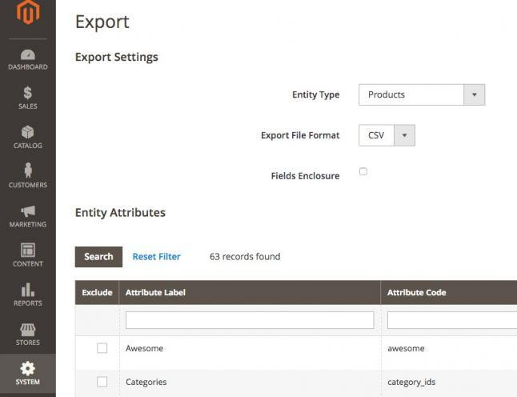

Now you should exclude the unnecessary attributes from the list by selecting them and then click on Continue from the bottom of the page.This will save a new file on your computer with a name similar to catalog_product_YYYYMMDD_randomnumber.csv .The file will include columns for each of the attributes you have defined for your products. Open it in a spreadsheet program (MS Excel, Open Office Spreadsheet) and add the products you would like to import. Make sure you are copy/pasting the corresponding attributes in the correct columns. Also here is when you will have to add the category IDs. Use the IDs from the text file you saved earlier and put the corresponding category ID for the products you are adding.

Once you have accomplished the above go back to the Magento administrator area and go to System menu > Data transfer section > Import. Now select Products from the Entity Type dropdown. After that select Products from Entity Dropdown, and Add/Update from Import Behaviour dropdown. Now upload the CSV file by clicking on the Browse button next to Select File to Import. If you have added images, you should also specify the path on the server where you uploaded them. Add the corresponding path to the Images File Directory section.

When ready click on the Check data button. If there are no issues or error with the import, a File is vaild! message and Import button would appear.

18 | P a g e
Magento – Ecommerce website development
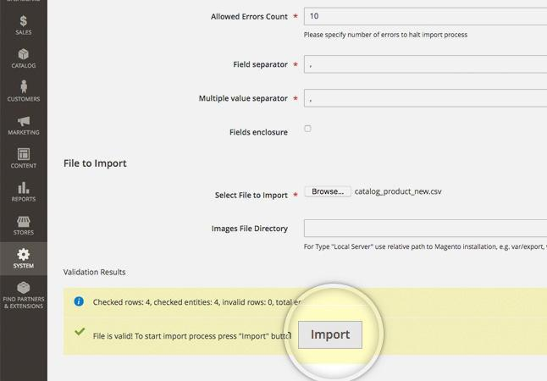

To initiate the process click on the Import button. When the import completes you will get the Import successfully done message.
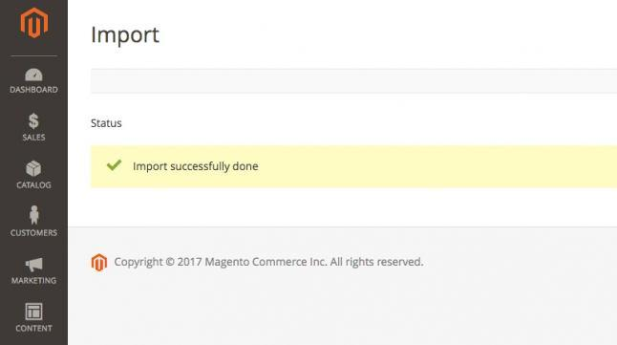

19 | P a g e
Magento – Ecommerce website development

Task 6: Product Quality

Magento provides you with an easy and yet powerful way to manage your product quantities. To do this, first login you Magento admin area and go to Catalog -> Products.
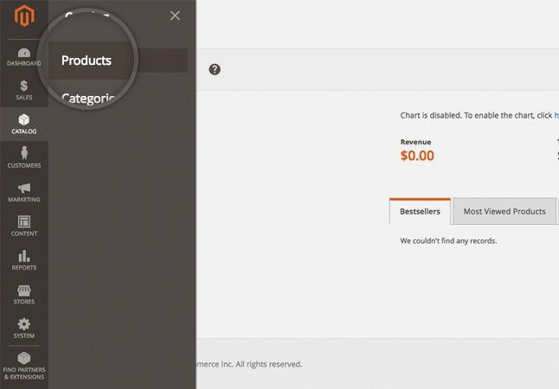

On this page, you will see a list of all of the products you've added to your Magento store. Locate the one you want to edit the quantity for and click on it to edit it.
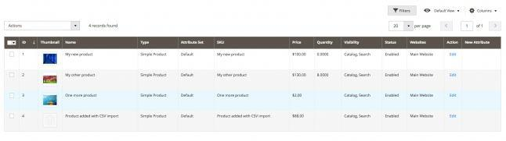

Doing so will take you to the page where you can edit every aspect of this product. Scroll down to the Quantity section and add the available amount of this product.

20 | P a g e
Magento – Ecommerce website development
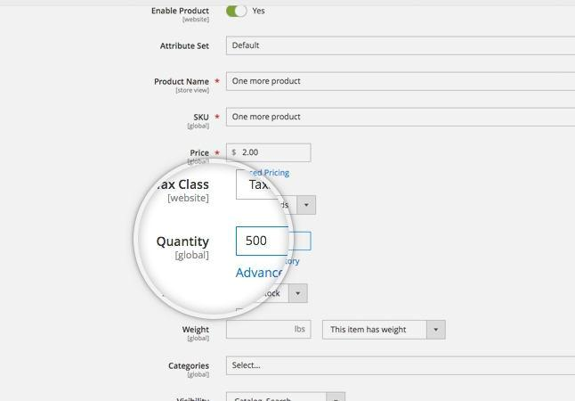

That's it, you can now track number of products of this type that you have in stock.

Task 7: Category Mnagement

This section covers the following topics:

How to create a category in Magento

How to add a category image in Magento

How to list all available categories in Magento

Magento categories are a useful way to sort and organize your product. In this section, we will show you how to create and manage categories in your Magento store.

How to create a category in Magento

In order to create a new category for your products, go to your Magento admin area > Catalog > Categories. On the left you will see the available categories (if any) and above them you will see two options - Add Root Category and Add Subcategory.

21 | P a g e
Magento – Ecommerce website development
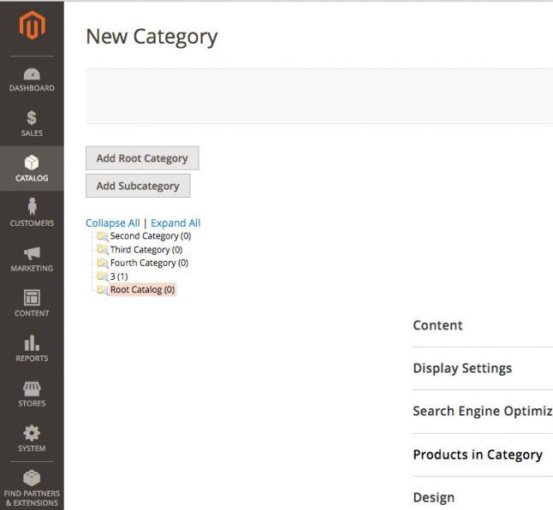

For the purpose of this section we would create a new subcategory by clicking on the Add subcategory button. You should fill in its Name, and toggle the Enable Category and Include in Menu buttons to Yes to include it in the navigation menu. These are the General Information settings for the category.

From the other tabs available you can also manage:

Content - here you may add category image, description, Add CMS Block;

Display Settings - here you can set category Display Mode, whether it is Anchor (i.e. whether or not it should inherit the products in its subcategories) and the product listing sorting options;

Search Engine Optimization - in this tab you may choose URL key, which, if set, will be used in the links to this category. This is useful for SEO purposes - when sites are indexed, it is considered a plus to have as many relative keywords as possible in the URL. If the category is called "PC", you may want to set this field to "personal-computers" to include two additional keywords in the link.

Category Products - this tab allows you to add existing products to the category

22 | P a g e
Magento – Ecommerce website development

Custom Design - from this tab you can select the design for this category, as well as its layout;
Schedule Design Update - this tab allows you to schedule the update for a certain time.

How to add a category image in Magento

Adding a Magento category image is simple. From the Magento admin area > Catalog > Categories select the category which you want to add an image to. Then click the Content tab and click on the Upload button next to the Category Image field.
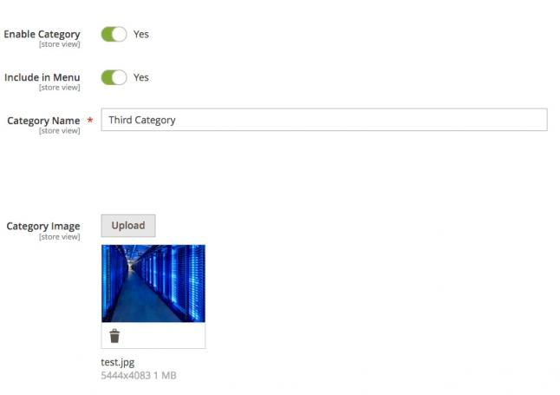

Locate the image you want to set for this category on your computer. The image will appear in the Category Image field and you should click Save to apply the changes.

How to list all available categories in Magento

If you want to get a list of all available Magento categories, go to your Magento admin area > Catalog > Categories. From the Categories menu on the left click Expand All and your whole category tree will be displayed.

23 | P a g e
Magento – Ecommerce website development

Task 8: Product price management

Magento provides you with a lot of options for the prices of your products. You can configure special prices, timed promotions and much more. To start editing your product prices, first login to your Magento admin page and go to Catalog -> Products.
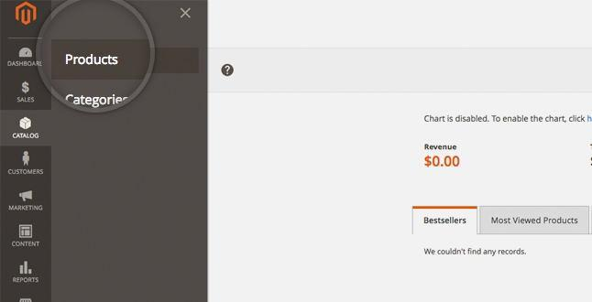

Now, locate the product whose price you want to modify and click on it to open up the Edit screen.

Then next to the Price section you would see Advanced pricing.
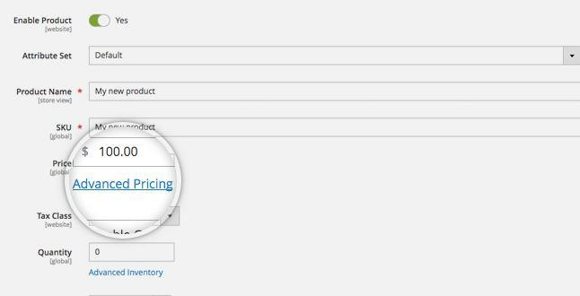

Click on the Advanced pricing link to open up a pop up window where you can set the pricing options.

24 | P a g e
Magento – Ecommerce website development
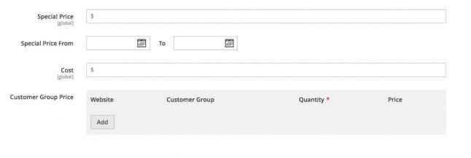

Special Pricing is a discounted price off of the retail price. It is most often used when an item is on sale. Special price can be set up with specific dates ranges so that you don't need to manually update each product when the sale is over. It can be configured via the Special Price From menu.

The Cost section is used to assign a cost price as well so you can manage profitability a lot easier.

To setup tier pricing, you should use the Customer Group Price. If you store has several websites, select the Website the tier pricing should be applied for. Select a Customer Group that the tier pricing should be applied for as well. In the Quantity field, enter the quantity that must be orders to receive the tier price and in the Price field, you should enter the price for specific amount of products.

Task -9

Create 3 products each in 2 categories (Electronics, Travel): Attach image and give dimension, color, size and SEO keyword Read and follow the steps below

It is rather inconvenient to manually add a large number of products at once to a Magento installation. Inserting products one by one will take a long time especially when you have hundreds or thousands of products. In such cases you need an automatic way to add all those products to your Magento online store. We will address all steps you need to take in order to achieve a successful import.

First, access your Magento administrator backend and go to Catalog -> Categories.

25 | P a g e
Magento – Ecommerce website development

Create all product categories you will need. You can do so by filling the form displayed below:

When you fill the form with all the information you like click the Save Category button.

Bear in mind that at this point you should make note of the newly created category IDs. It would be best to save them in a simple text file as you will need them for the import. The category ID will be displayed upon saving the category.

26 | P a g e
Magento – Ecommerce website development

If you plan to have additional attributes for the products you are importing you will need to create those via Stores menu > Product under the Attributes section. You can use this functionality to add all custom attributes that are not present by default in a standard Magento installation. Note also that you can add additional attributes later at the moment you are creating a sample product. It is up to you whether to create the attributes before that or at the point you are creating the first product.

The next step is to manually add a product to your Magento installation. You will later export this product and use it as a template for importing the large batch. Make sure you include all attributes you will use for the products you are going to import in the sample product.

Once you create the new product and save it it will appear in the products list for your Magento store.

You are now ready to make the sample export that you will use as a template. In the Magento administrator area go to System menu > Data transfer section > Export. This would redirect you to a new page where you should select Products from Entity Type Dropdown and CSV from Export

File Format.

27 | P a g e
Magento – Ecommerce website development

Now you should exclude the unnecessary attributes from the list by selecting them and then click on Continue from the bottom of the page.This will save a new file on your computer with a name similar to catalog_product_YYYYMMDD_randomnumber.csv .The file will include columns for each of the attributes you have defined for your products. Open it in a spreadsheet program (MS Excel, Open Office Spreadsheet) and add the products you would like to import. Make sure you are copy/pasting the corresponding attributes in the correct columns. Also here is when you will have to add the category IDs. Use the IDs from the text file you saved earlier and put the corresponding category ID for the products you are adding.

Once you have accomplished the above go back to the Magento administrator area and go to System menu > Data transfer section > Import. Now select Products from the Entity Type dropdown. After that select Products from Entity Dropdown, and Add/Update from Import Behaviour dropdown. Now upload the CSV file by clicking on the Browse button next to Select File to Import. If you have added images, you should also specify the path on the server where you uploaded them. Add the corresponding path to the Images File Directory section.

When ready click on the Check data button. If there are no issues or error with the import, a File is vaild! message and Import button would appear.

28 | P a g e
Magento – Ecommerce website development

To initiate the process click on the Import button. When the import completes you will get the Import successfully done message.

29 | P a g e
Magento – Ecommerce website development

Task: 10

Transfer Magento content (Backup)

This section covers the following topics:

Backup the Magento MySQL Database Transfer all Magento Files
Adjust the Magento Configuration Restore the Magento Database

This section provides detailed information on how to completely transfer a Magento store from one host to another. The same instructions apply if you want to move your Magento application from one folder to another.

Backup the Magento MySQL Database

On SiteGround servers you have phpMyAdmin included by default in the cPanel for your account. In other cases you will have to use the same tool or a similar one that is capable of exporting your MySQL database. Detailed information on how to perform a MySQL backup can be found in our MySQL Section.

Alternatively, if you don’t have phpMyAdmin installed but you have shell access you can use the mysqldump tool. The syntax is as follows:

1 mysqldump -h HOST -u USER -p DATABASENAME > FILENAME.sql

where:

HOST is the database server hostname or it can be omitted if you are running the MySQL server locally;
USER - a user with full privileges to the Magento database;

DATABASENAME - is the full name of the database which Magento is running; FILENAME - can be anything you find suitable for the backup file.

Also, if you have Plesk, DirectAdmin or any other web hosting management tool, you can look at the available options. Many panels allow you to dump the database with just a few clicks. For example cPanel does have an option for this.

Transfer all Magento Files

You will need to download all files from your current store and upload them to the new location. This can be a time consuming task considering that a standard Magento installation consists of many files. A good alternative is to archive the files prior to downloading/uploading them if possible.

If you have SSH access you can log on your server -> magento installation directory and archive all the files using the following command:

30 | P a g e
Magento – Ecommerce website development

1 tar -czif ARCHIVENAME.tar.gz *

This will create a tarball archive of all the files in the directory.

You can then download the archive and easily upload it to the new location. To extract it use the following command in the desired destination folder for the Magento installation:

1 tar -xzif ARCHIVENAME.tar.gz

Adjust the Magento Configuration

After the files are restored you should alter the configuration file in order to match the new settings. All you need to change here is the database details at the new location. Those are stored in the app/etc/env.php file. The lines you need to alter are:

1 'host' => 'yourhost',

- 'dbname' => 'your_db',
- 'username' => 'your_user',

- 'password' => 'yourpassword',

where:

yourhost should be the database hostname, most commonly - localhost; your_user is a user that has full privileges to the database;

yourpassword is the password for the database user;

your_db is the complete database name for the database you are going to use with the transferred Magento.

Restore the Magento Database

Once you have adjusted the options above you should restore the database at the new location.

A good practice is to add several options in the MySQL backup file prior to uploading it. The following should be added at the beginning of the SQL file:

SET SQL_MODE="NO_AUTO_VALUE_ON_ZERO";SET

- @OLD_CHARACTER_SET_CLIENT=@@CHARACTER_SET_CLIENT;SET

- @OLD_CHARACTER_SET_RESULTS=@@CHARACTER_SET_RESULTS;SET

- @OLD_COLLATION_CONNECTION=@@COLLATION_CONNECTION;SET NAMES

- utf8;SET

- @OLD_UNIQUE_CHECKS=@@UNIQUE_CHECKS, UNIQUE_CHECKS=0;SET

- @OLD_FOREIGN_KEY_CHECKS=@@FOREIGN_KEY_CHECKS,

- FOREIGN_KEY_CHECKS=0;SET

- @OLD_SQL_MODE=@@SQL_MODE, SQL_MODE='NO_AUTO_VALUE_ON_ZERO';SET @OLD_SQL_NOTES=@@SQL_NOTES, SQL_NOTES=0;

The next option should be added at the end of the file after all other queries:

31 | P a g e
Magento – Ecommerce website development

- SET SQL_MODE=@OLD_SQL_MODE;SET

- FOREIGN_KEY_CHECKS=@OLD_FOREIGN_KEY_CHECKS;SET

- UNIQUE_CHECKS=@OLD_UNIQUE_CHECKS;SET

- CHARACTER_SET_CLIENT=@OLD_CHARACTER_SET_CLIENT;SET

- CHARACTER_SET_RESULTS=@OLD_CHARACTER_SET_RESULTS;SET

- COLLATION_CONNECTION=@OLD_COLLATION_CONNECTION;SET

- SQL_NOTES=@OLD_SQL_NOTES;

You can now import the database using phpMyadmin -> Import or another MySQL tool depending on what kind of access you have to the website.

In case you would like to restore the database via a shell command you can use the following:

1 mysql -h HOST -u USER -p DATABASENAME < FILENAME.sql

and enter the password for the database user when asked.

Note that if the Magento online store is supposed to work with a different domain name at the new location you should alter the entries for it in the MySQL database.

The table you should edit is core_config_data and the values you need to change are in the path column. Change the web/unsecure/base_url and web/secure/base_url to match the new domain name by altering the value column for both records.

The last step is to clear the Magento cache. You can do this either via the Magento admin panel > System > Tools > Cache management or by deleting the contents of the var/cache and var/session folders inside your Magento installation directory.

That is all. Your Magento should now be properly functioning at the new location.

32 | P a g e
Magento – Ecommerce website development

Task 3:

Configure Magento with SSL

The private SSL certificate is an important upgrade to your website. The basic function of an SSL is to encrypt all communication between the browser and the server, ensuring that all data goes through a secure (HTTPS) connection. An SSL certificate is a necessity when you want to operate an online shop and process the sensitive customers data through your software. It helps you gain your clients' trust and increase your web site's search engines rank. You can choose a private SSL from the SiteGround SSL Certificate page.

To configure Magento to work with your SSL certificate, first you need to login to your admin area and go to Stores -> Configuration. Then expand the General tab and click on the Web menu.
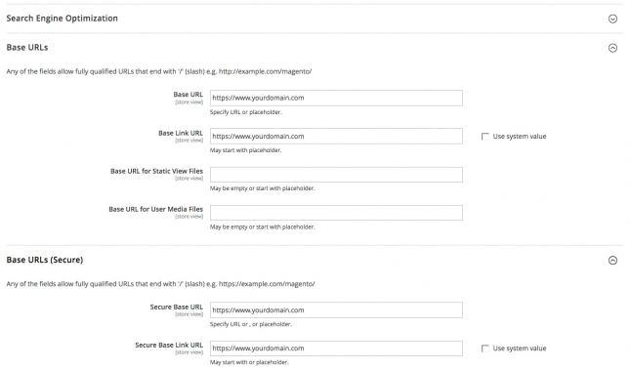

On this page, you will see many options that you can configure. However, focus only on the Base URLs and Base URLs (Secure) tab. In it, make sure that you've set the Base URLs, Base Link URL, Secure Base URL and Use Secure Base Link URL to your domain with HTTPS. Doing this will make your Magento application work with SSL only.

That's it, your Magento store is now configured to work over SSL!

